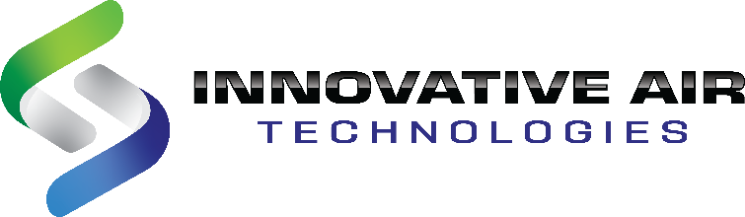
16200 Georgia Peach Ave, Covington GA 30014
Ph# 770-788-6744, Ph# 888-Dry-Air7

About IAT
Since the inception of Innovative Air Technologies in 2001, we've desired to change the status quo when it comes to low humidity systems. Our vision is to enrich the lives of our customers by offering quality, flexible, value-driven solutions for any dehumidification application.
That's IAT!

This drives us to innovate with our products and offer an industry-leading customer service experience from planning to implementation and beyond.

Job Title: Refrigeration Technician

What we are looking for in a Team member:
We are looking for a Refrigeration Technician to help build and produce products as well as help support our customers and engineering group. This person will work to ensure the piping and operation of our dehumidifiers helps to enrich the lives of our customers. We are looking for someone self-motivated, positive, and excited about making an impact, innovations, and world-class customer experience.

Primary Responsibilities:
- Perform standard duties of refrigeration technician:
  - Aid in layout and attachment of condensing units and coils.
  - Copper piping sizing and layout.
  - Assembly and brazing of piping joints.
  - Control and power wiring in of condensers, valves and louvers.
  - Coolant charging of condensers.
  - Monitor and maintain stock levels of piping supplies.
  - Work with controls team to adjust PLC controls as needed.
  - Assist in assembly of pre-purchased gas trains.
  - Trouble shoot issues during factory testing.
  - When visiting the field, generate field reports.
  - Replace OEM defective parts during factory assembly.
  - And other typical HVAC technician duties….
- When available, assist electrical team with basic wiring of dehumidifiers.
- Do factory start-up and adjusting of the system to ensure it meets specifications prior to shipment.
- When needed, travel to sites to conduct unit start-up & field service calls.
- Support customer and job site questions when called upon by engineering or manager.
- Possibly aid in the training ref. contractors to assist in service calls.
- Work with engineering to help develop and maintain production standards for condenser installation.
- Look for and help implement processes, tools, and standards to improve product and minimize rework and lead time.
- Work with engineering on product development to help minimize start-up time and prevent service issues before they can happen.

Basic Qualifications:
- Min. H.S. diploma/GED
- Professional, positive, and motivated personality
- Ability to read and understand electrical & mechanical drawings
- Min. 5 years of field service experience on Dehumidifiers, HVAC or other air handling equipment
- EPA certified/licensed
- Working knowledge of control and power wiring
- Working knowledge of electrical and sheet metal design
- Excellent communication and people skills
- Good working knowledge of production and manufacturing processes
- Proven ability to analyze and resolve problems quickly and effectively
- Ability to possibly travel to job sites in locally and in other states

Preferred Qualifications:
- Welding experience
- Metal fabrication experience
- Advanced training on HVAC
- Experience with dehumidifiers
- Good technical writing skills.
- Min. 2 years of experience with PLC, controllers, or other smart controls
- Sales experience

Job Type: Full-time
Experience: min. 5 years
Benefits: 401K, Health Plan, Bonuses, Monthly Lunches, and Company Sponsored Team-building Events.
Travel: Max. 50% for site visits but will reduce as team grows.

